CASE STUDIES

Name: MUDDANAGIRI DURGA SAI MANASA
Roll.No: 2520030500
Section: 1[Practical]

Task 1: Create and Manage Files
Objective: Practice creating, listing, viewing, and deleting files.

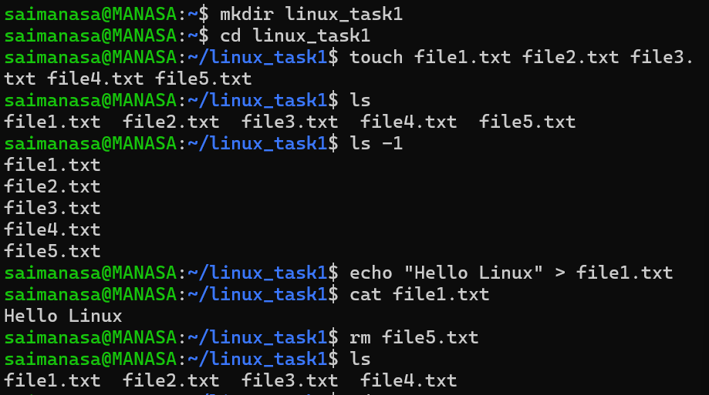

Task 2: Copy and Move Files
Objective: Practice copying and moving files and directories.

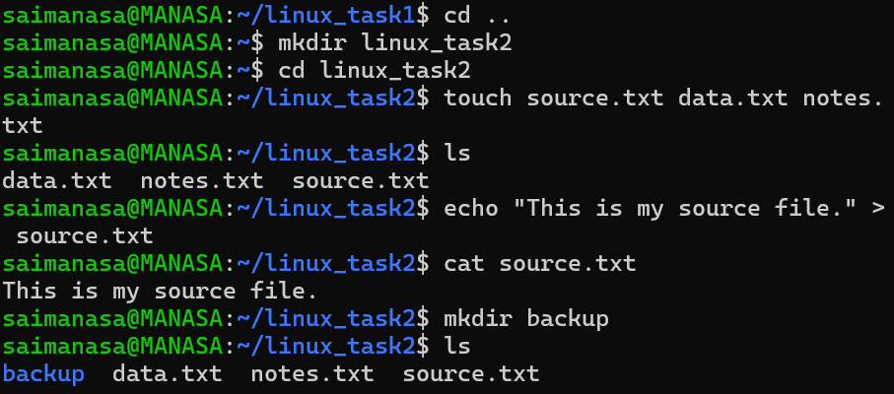

Task 3: Working with head and tail
Objective: Practice viewing specific portions of a file.

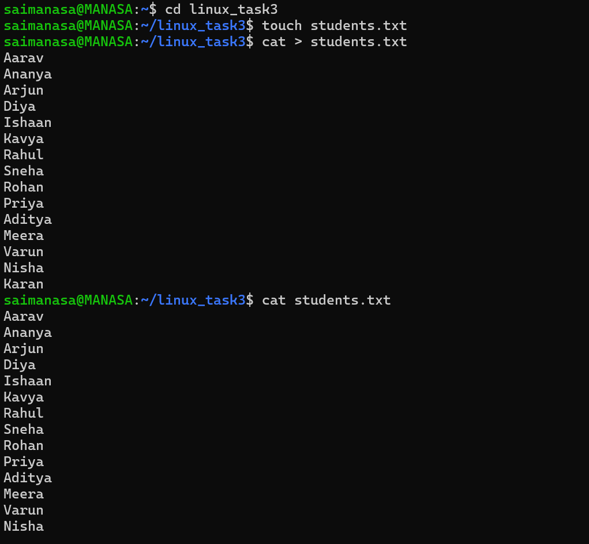

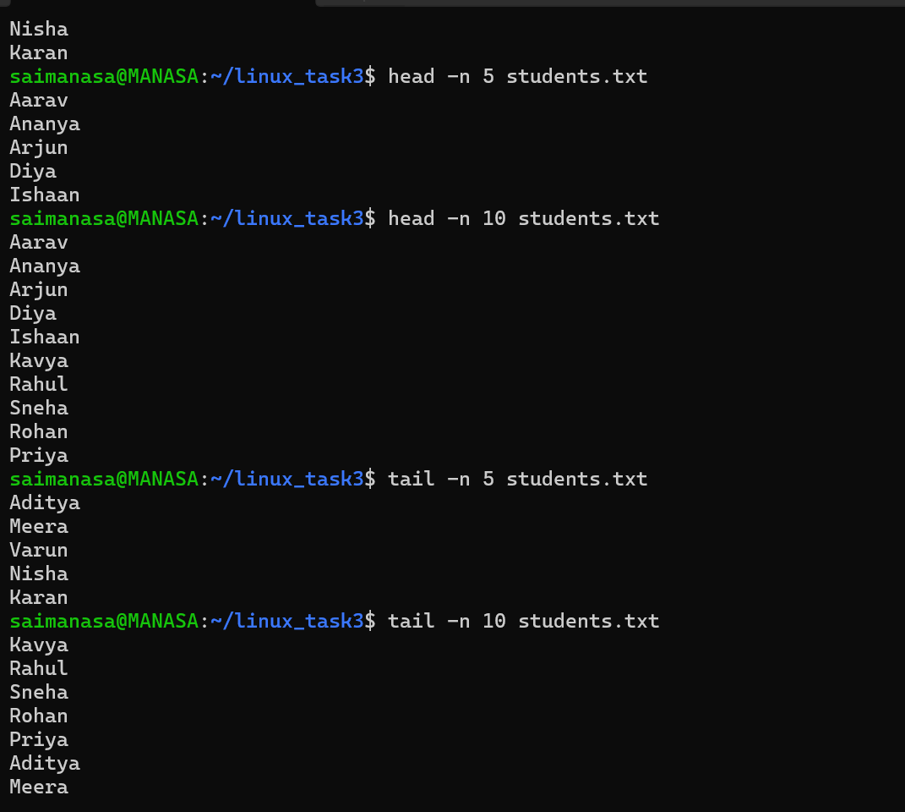

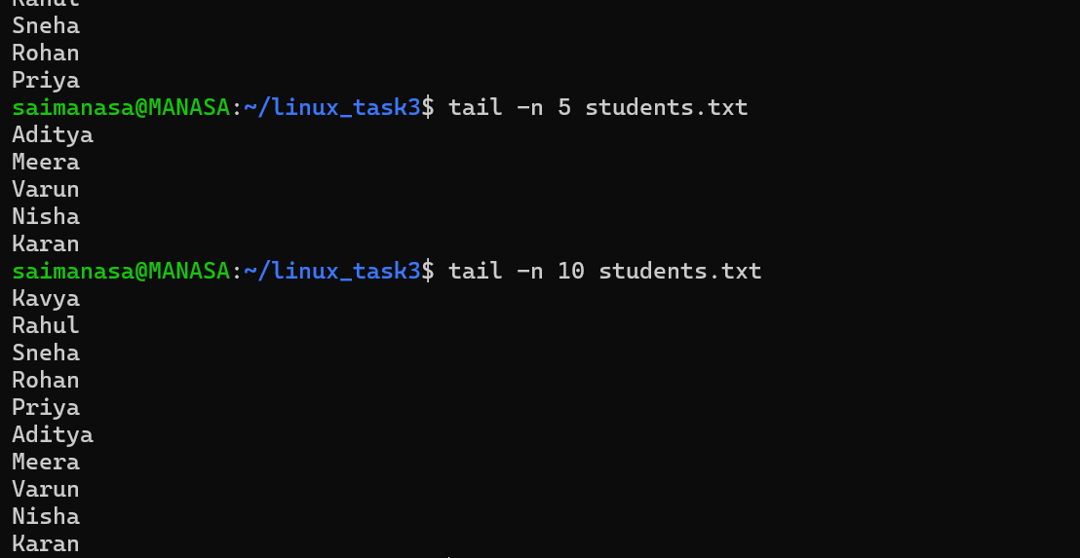

Task 4: Organize Files
Objective: Organize files into different directories using mv.

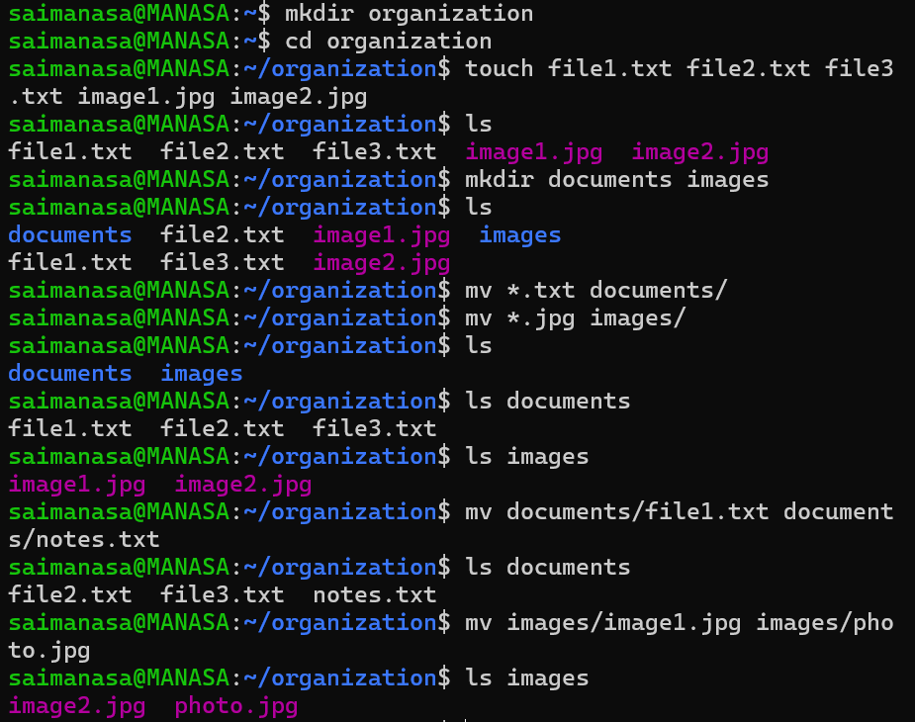

Task 5: Directory Management
Objective: Practice creating nested directories and removing them.

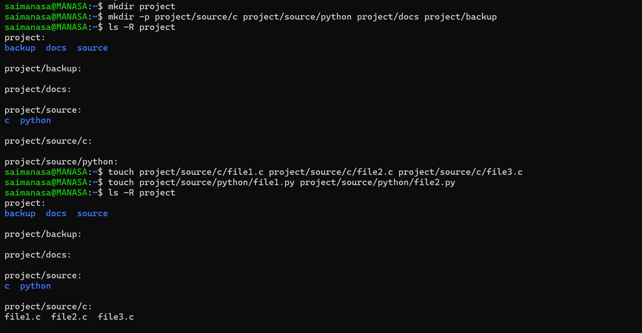

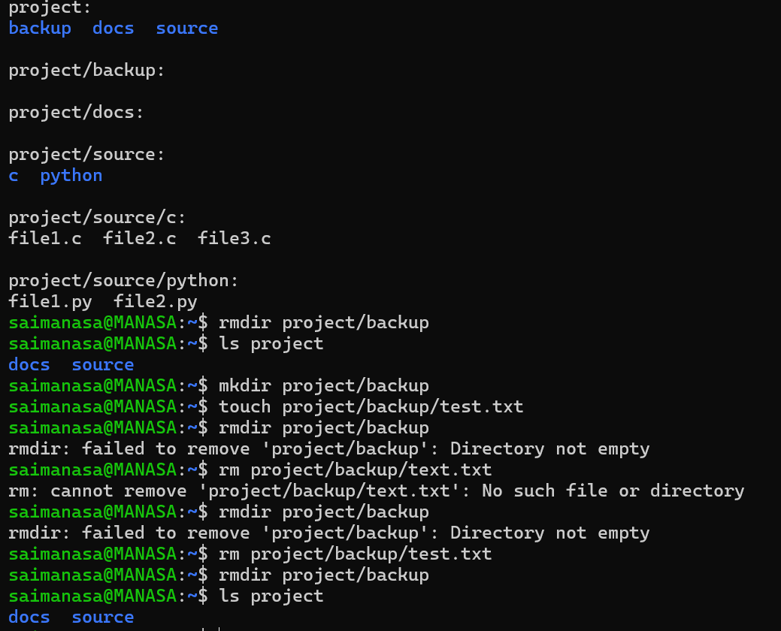

Task 6: File Permissions
Objective: Practice viewing and changing file permissions using chmod.

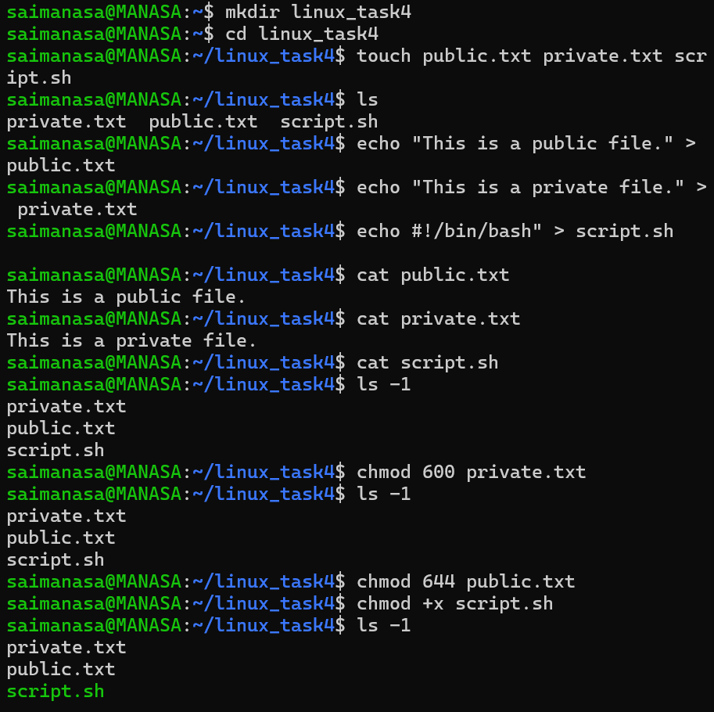

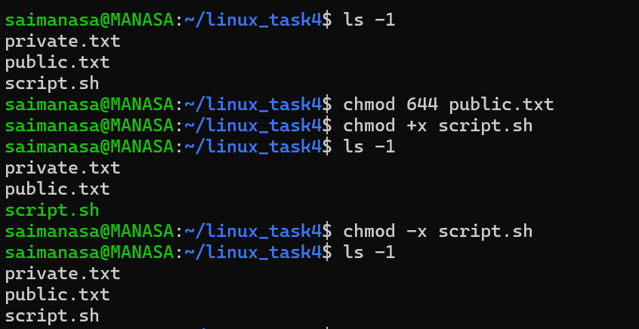

Task 7: Permission Lab
Objective: Explore the effects of read, write, and execute permissions.

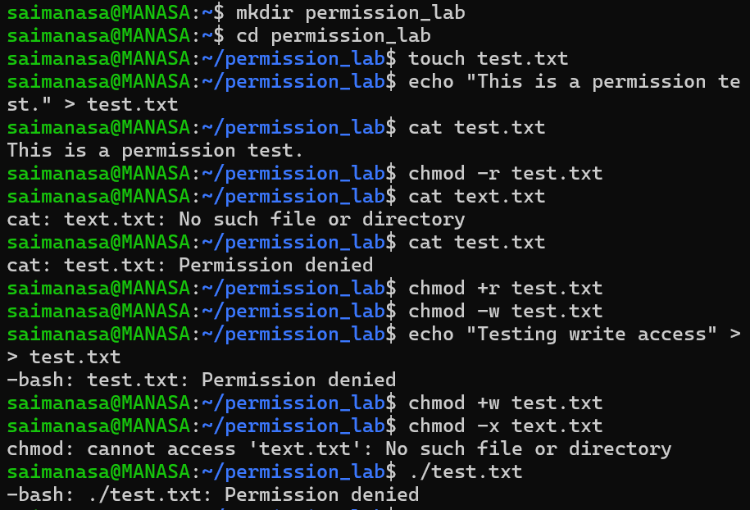

Task 8: Backup and Restore Files
Objective: Practice backing up, removing, and restoring files using cp, mv, and rm.

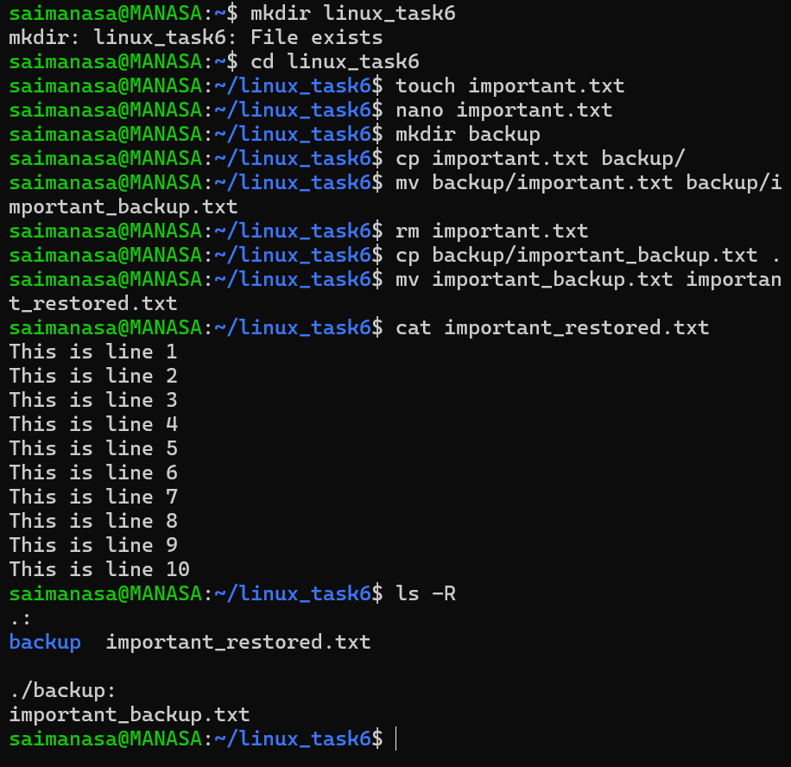

Task 9: Project Directory Management
Objective: Practice organizing a project with directories, viewing file contents, and managing files with cp, mv, chmod, and rm.

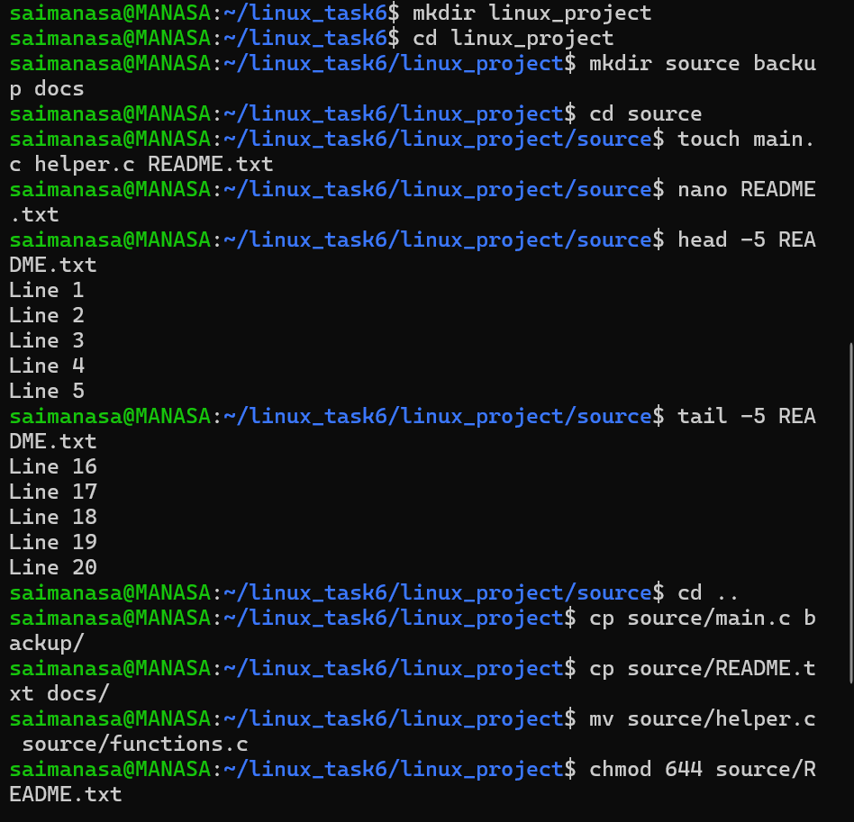

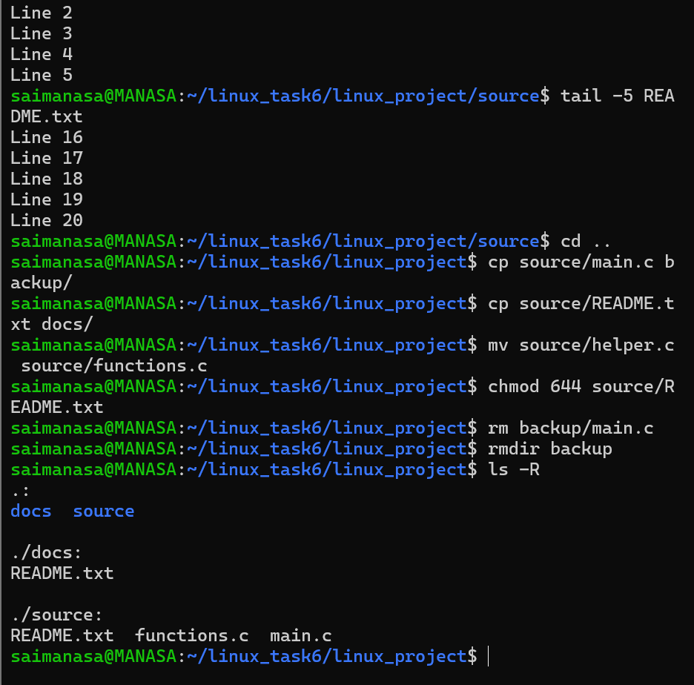

Task 10: Student Portal Project Setup
Objective: Practice building a multi-directory project structure and managing files with cp, mv, chmod, and rm.

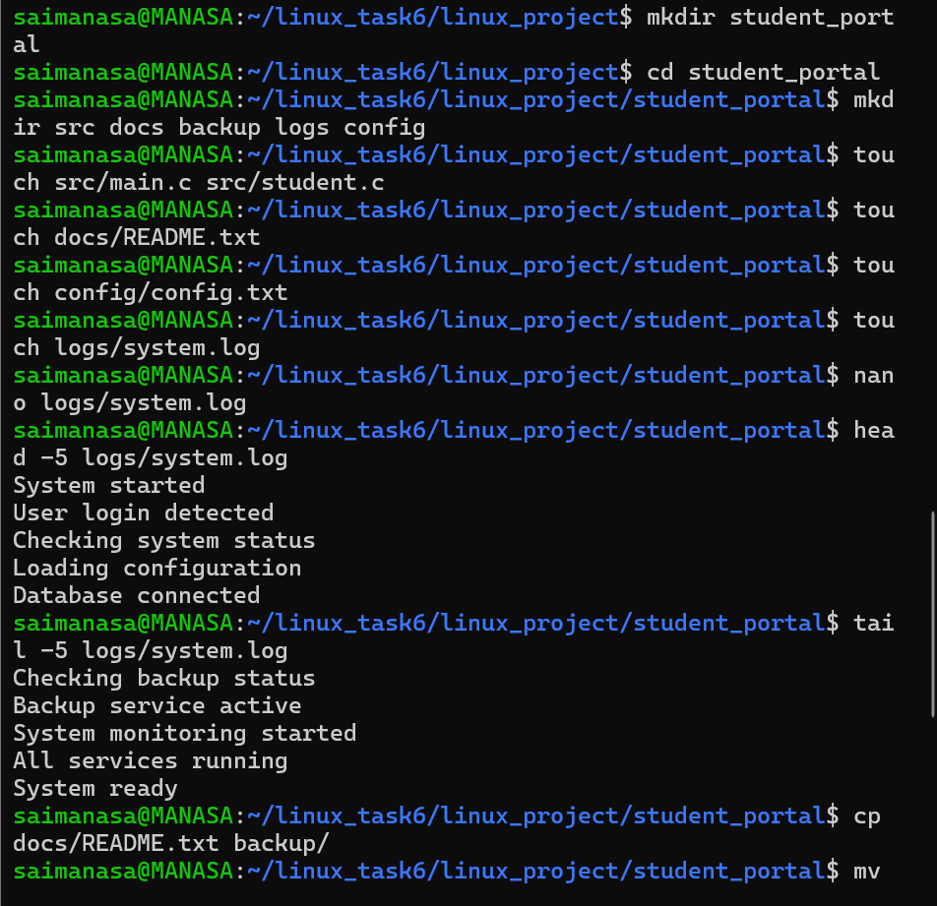

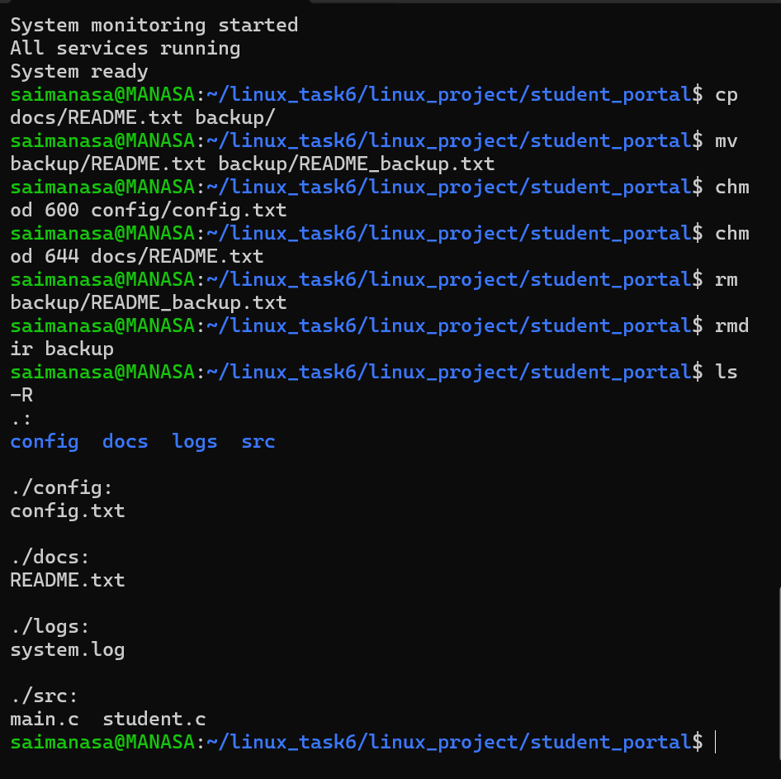

Task 11: Process Creation with fork()
Objective: Compile and run a C program to observe parent and child process behavior.

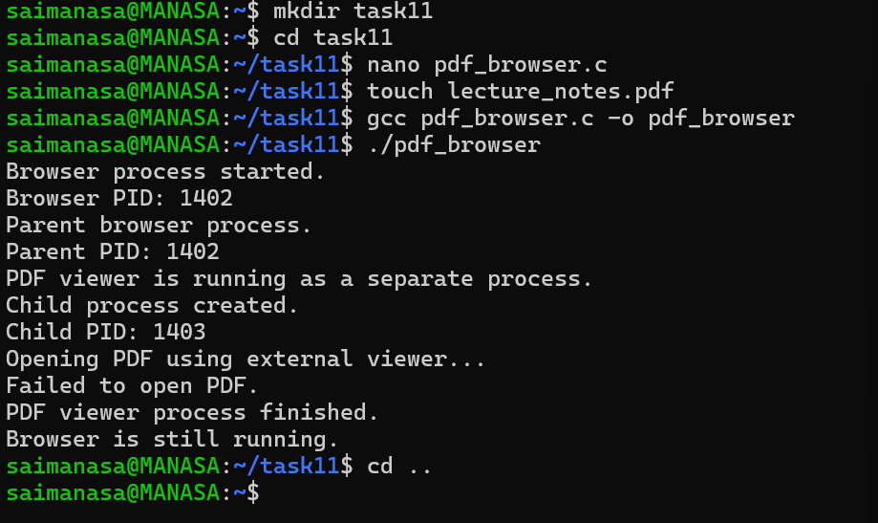

Task 12: Building a Simple Shell
Objective: Write and run a basic C program that simulates a simple command-line shell.

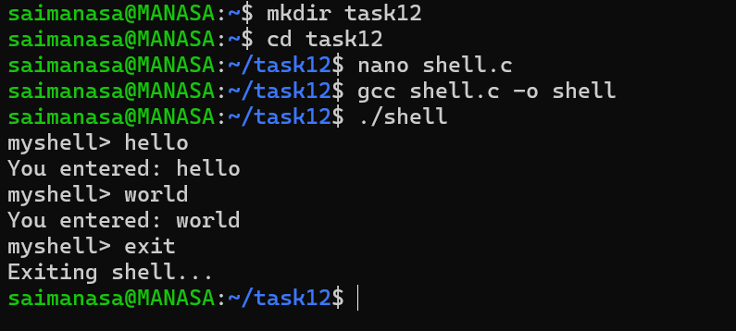

Task 13: Shell with Command Handling
Objective: Extend the simple shell to support a help command and handle unknown commands.

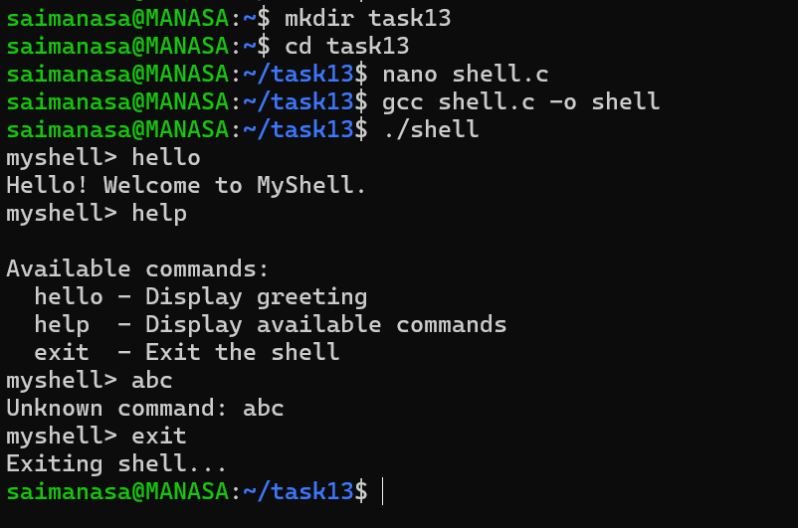

Task 14: Shell with Command History
Objective: Extend the shell to record and display a history of entered commands.

